 Translated from Chinese (Simplified) to English - www.onlinedoctranslator.com
Table of contents
1. Product Introduction 2
1. Overview 2
2. Features 2
3. Application areas 2
2. Electrical, Mechanical and Environmental Indicators 2
1. Electrical specifications 2
2. Usage environment and parameters 3
3. Mechanical installation diagram 3
4. Enhance heat dissipation 4
3. Driver interface and wiring introduction 4
1.Interface Description 4
2. Control signal interface circuit 6
3. Control signal timing diagram 6
4.Control signal mode setting 7
5.Wiring requirements 7
4. DIP switch function setting 7
1. Current setting 7
2. Quiescent current setting 7
3. Segment settings 8
4. Working mode settings 8
5. Power supply selection 8
6. Protection function 9
1. Short circuit protection 9
2.Overvoltage protection 9
3.Undervoltage protection 9
4. Phase loss protection 9

DS556 Digital Two-Phase Stepper Driver
- Product Introduction
- Overview
DS556 is a two-phase digital stepper driver with serial port debugging function newly launched by Ge Rui IoT Technology Co., Ltd. It adopts the latest 32-bit DSP control technology and integrates MODBUS-RTU standard protocol specifications. Users can set any subdivision within 200-40000 and multiple parameters such as working mode through the host computer debugging software, which greatly enriches the practical functions of the product and can meet the application needs of most occasions.
The DS556 driver adopts a servo-like control principle, integrating vector control technology, built-in micro-segmentation technology, and adaptive filtering technology, which greatly optimizes the performance of the stepper motor. It runs smoothly at low, medium and high speeds with low noise. The precise and smooth pure sine current vector control technology effectively reduces the heating of the motor.
The driving voltage range of the DS556 driver is DC20~50V, and it is suitable for two-phase hybrid stepper motors with a peak current below 5.6A and an outer diameter of 42~86mm.
- Features
●With serial port debugging function ●External dial selects the driver working mode
●New 32-bit DSP technology ●Small size, easy to install
●Can drive 4, 6, 8-wire two-phase stepper motor Optically isolated differential signal input
●Built-in micro-segmentation ●Pulse response frequency up to 200KHz (higher frequency can be adjusted)
●Subdivision setting range 200-40000 ●Current can be set arbitrarily
●Precise current control greatly reduces motor heating ●Low vibration and low noise
●The current is automatically halved when stationary ●With overvoltage, undervoltage, overcurrent and other protection functions
- Application Areas
Suitable for various small and medium-sized automation equipment and instruments, such as: engraving machines, marking machines, cutting machines, plotters, CNC machine tools, automatic assembly equipment, etc. It has a particularly good application effect in equipment applications where users expect low noise and high speed.

2. Electrical, Mechanical and Environmental Indicators
- Electrical Specifications
illustrate | DS556
illustrate | Minimum | Typical Value | Maximum | unit
Output Current | 1.4 | - | 5.6 | A
Input power voltage | 20 | 36 | 50 | VDC
Control signal input current | 7 | 10 | 16 | mA
Step pulse frequency | 0 | - | 200 | KHz
Insulation resistance | 50 |  |  | MΩ
- Use environment and parameters
Cooling method |  | Natural cooling, fan cooling
Usage Environment | occasion | Do not place it near other heating equipment. Avoid dust, oil mist, corrosive gas, high humidity and strong vibration. Flammable gas and conductive dust are prohibited.
Usage Environment | temperature | 0——50℃
Usage Environment | humidity | 40-90%RH
Usage Environment | vibration | 10~55Hz/0.15mm
Storage temperature |  | -20℃~65℃
- Mechanical installation drawing
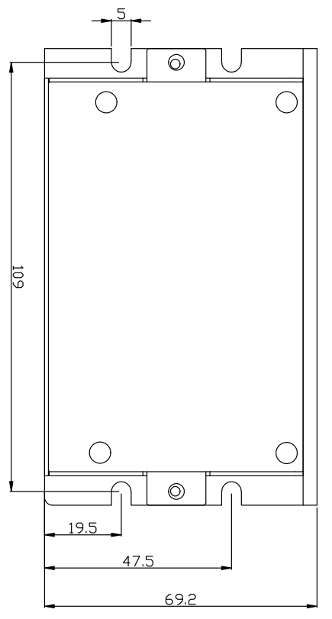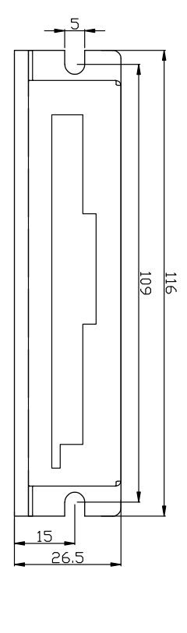
Front installation diagram Side installation diagram
Figure 1 Installation dimensions (unit: mm)
※Side installation is recommended for better heat dissipation. When designing the installation dimensions, pay attention to the terminal size and wiring!
- Enhanced heat dissipation
- The reliable operating temperature of the driver is usually within 50℃, and the operating temperature of the motor is within 80℃;
- It is recommended to select the automatic half-current mode when using, that is, when the motor stops, the current is automatically reduced by half to reduce the heating of the motor and driver;
- When installing the driver, please install it sideways and allow strong air convection to form on the bottom of the driver. If necessary, install a fan near the driver inside the machine to form air convection to assist in heat dissipation and ensure that the driver operates within a reliable operating temperature range.

3. Driver interface and wiring introduction
- Interface Description
- Control signal interface
name | Function
PLS+ | Pulse control signal: +5V-+24V can be driven, rising edge is effective, every time the pulse changes from high to low, the motor takes a microstep. In order to reliably respond to the pulse signal, the pulse width should be greater than 2μs.
PLS-
DIR+ | Direction control signal: can be driven by +5V-+24V, high/low level signal. To ensure reliable commutation of the motor, the direction signal should be established at least 5μs before the pulse signal. The initial running direction of the motor is related to the motor wiring. Interchanging any phase winding (such as A+ and A-) can change the initial running direction of the motor.
DIR-
ENA+ | Enable control signal: +5V-+24V can be driven, high/low level signal. Used to enable or disable the operation of the motor. When ENA+ is connected to +5V and ENA- is connected to a low level, the driver will cut off the current of each phase of the motor to put the motor in a free state, and the step pulse will not be responded to at this time. When this function is not needed, the enable signal terminal can be left floating.
ENA-
- Output signal interface
name | Function
ALM+ | Alarm signal output: When overcurrent, overvoltage, and undervoltage alarms occur, the alarm signal output is valid;  ALM+ is connected to the pull-up resistor to the positive pole of the output power supply, and ALM- is connected to the signal input terminal of the controller; the maximum driving current is 50mA.
ALM-

- Strong power interface
name | Function
GND | DC power ground
+VDC | Positive power supply, range: DC20~50V, recommended +36V
A+、A- | Motor A phase coil
B+, B- | Motor B phase coil
- 232 communication interface
The serial communication interface of the DS556 driver uses an RJ12 terminal, which can be connected to the PC through a dedicated serial cable via a USB to TTL serial conversion tool. Do not plug or unplug the power supply! On the PC side, customers can set the required parameters, such as current, subdivision, working mode, etc. For details, please refer to the upper computer software interface.
Terminal No. | symbol | name | illustrate
1 | GND | RS232 communication ground | 0V
2 | TXD | RS232 transmitter
3 | NC | - | Internal Use
4 | RxD | RS232 Receiver
5 | NC | - | Internal Use
6 | NC | - | Internal Use
▶Note: The cable connecting DS556 and PC must be a dedicated cable (provided randomly depending on the user's needs). Please confirm it before use to avoid damage.
- Status Indicator
The green LED is the power indicator light. When the driver is powered on, the LED is always on; when the driver is powered off, the LED is off.
The red LED is a fault indicator. When a fault occurs, the indicator flashes in a cycle of 3 seconds. When the fault is eliminated by the user, the red LED goes out. The number of times the red LED flashes in 3 seconds represents different fault information. The specific relationship is shown in the following table:
Serial number | Number of flashes | Red LED flashing waveform | Fault Description
1 | 1 | 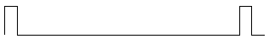 | Overcurrent, phase short circuit or poor contact fault
2 | 2 | 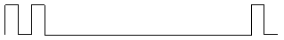 | Overvoltage fault (voltage>DC50V)
3 | 3 | 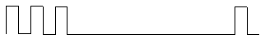 | Undervoltage fault (voltage<DC20V)
4 | 5 | 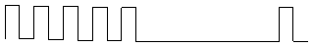 | Motor open circuit(Phase missing)
- Control signal interface circuit
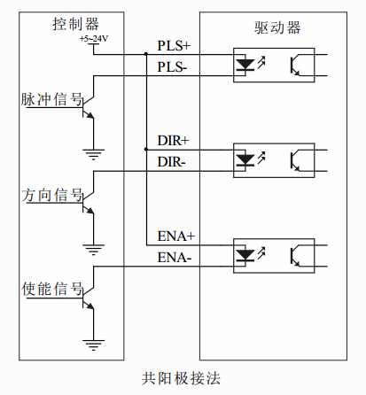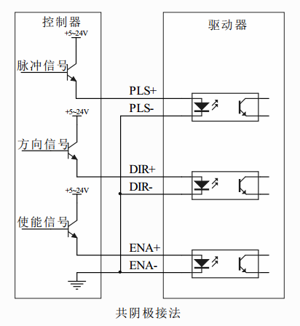
Figure 2 Input interface circuit
The DS556 driver control signal end adopts a differential interface circuit, which is applicable to differential signals, single-ended common cathode and common anode interfaces, and has a built-in high-speed optocoupler, which has strong anti-interference ability in harsh environments. The interface circuit diagram is shown in Figure 2.
▶Note: DS556 is a 5V-24V universal driver, so the signal control end does not need a series resistor!
- Control signal timing diagram
In order to avoid some false actions and deviations, PLS, DIR and ENA should meet certain requirements, as shown in the following figure:
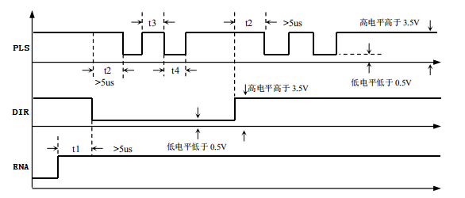
Figure 3 Control signal timing diagram
Notes:
- t1: ENA (enable signal) should be at least 5ms ahead of DIR and determined to be high. In general, it is recommended that ENA+ and ENA- be left floating.
- t2: DIR determines its state high or low at least 5μs in advance of the falling edge of PLS.
- t3: The pulse width is at least 2.5μs.
- t4: Low level width is not less than 2.5μs.
- Control signal mode setting
Pulse trigger edge selection: The rising edge or falling edge of the pulse can be set to trigger effectively through the PC software.
- Wiring requirements
- In order to prevent the driver from being interfered, it is recommended that the control signal use shielded cable, and the shield layer is short-circuited with the ground wire. Except for special requirements, the shield line of the control signal cable is grounded at one end: the host computer end of the shield line is grounded, and the driver end of the shield line is suspended. Only the same point is allowed to be grounded in the same machine. If it is not a real ground wire, there may be serious interference. In this case, the shield layer is not connected.
- The pulse and direction signal lines are not allowed to be wrapped side by side with the motor lines. It is best to separate them by at least 10 cm. Otherwise, the motor noise will easily interfere with the pulse direction signals and cause inaccurate motor positioning, system instability and other faults.
- If one power supply supplies multiple drives, they should be connected in parallel at the power supply. Chain connection from one drive to another is not allowed.
- It is strictly forbidden to plug or unplug the high-voltage terminals of the driver while it is powered on. When the motor is stopped, there is still a large current flowing through the coil. Plugging or unplugging the terminals while it is powered on will cause a huge instantaneous induced electromotive force that will burn out the driver.
- It is strictly forbidden to connect the wire end to the terminal after tinning it, otherwise the contact resistance may increase and the terminal may be damaged by overheating.
- The wiring ends must not be exposed outside the terminals to prevent accidental short circuits and damage to the driver.
- DIP switch function setting
The DS556 driver uses a 10-bit DIP switch, SW1-SW3 is used to set the current; SW4 selects full current or half current lock; SW5-SW8 is used for subdivision setting; SW9-SW10 is used for working mode selection. The detailed description is as follows:
SW1 | SW2 | SW3 | SW4 | SW5 | SW6 | SW7 | SW8 | SW9 | SW10
Current setting |  |  | Semi-stream | Segment settings |  |  |  | Working mode settings
- Current setting
Output peak current | Output effective current | SW1 | SW2 | SW3 | Current self-setting
1.4 | 1.0 | off | off | off | When SW1, SW2, and SW3 are all off, the required effective current value can be set through the PC software. The maximum value is 6000mA and the resolution is 1mA.
2.1 | 1.6 | on | off | off
2.7 | 1.9 | off | on | off
3.2 | 2.3 | on | on | off
3.8 | 2.7 | off | off | on
4.3 | 3.1 | on | off | on
4.9 | 3.5 | off | on | on
5.6 | 4.0 | on | on | on
- Quiescent current setting
The static current can be set with the SW4 DIP switch. Off means the static current is set to half of the dynamic current, and on means the static current is the same as the dynamic current. In general use, SW4 should be set to off to reduce the heat of the motor and driver and improve reliability. After the pulse input stops, the current is automatically reduced to half (the lock current percentage can also be set by the host computer software).
- Segment settings
Steps/turn | SW5 | SW6 | SW7 | SW8 | Segment Description
200 | on | on | on | on | When SW5, SW6, SW7, and SW8 are all off, the user can set any subdivision value from 200 to 40000 through the PC software, with a resolution of 1.
400 | off | on | on | on
800 | on | off | on | on
1600 | off | off | on | on
3200 | on | on | off | on
6400 | off | on | off | on
12800 | on | off | off | on
3600 | off | off | off | on
1000 | on | on | on | off
2000 | off | on | on | off
4000 | on | off | on | off
5000 | off | off | on | off
8000 | on | on | off | off
10000 | off | on | off | off
20000 | on | off | off | off
7200 | off | off | off | off
- Working mode settings
SW9 | SW10 | Working mode selection | Remark
off | off | Pulse+Direction | When SW9 and SW10 are both off, users can use the PC softwareSet the working mode yourself.
on | off | Pulse + direction with smoothing
off | on | Double Pulse
on | on | Spontaneous pulses

▶Note: After modification, power must be restarted for it to take effect.
- Power supply selection
The power supply voltage can work normally within the specified range. The DS556 driver is best powered by a regulated DC switching power supply. It should be noted that the output current range of the switching power supply must be set to the maximum. An unregulated DC power supply can also be used, but it should be noted that the peak value of the rectified voltage ripple should not exceed the specified maximum voltage. It is recommended that users use a DC voltage lower than the maximum voltage to avoid power grid fluctuations exceeding the driver voltage operating range.
▶Notice:
- When wiring, pay attention to the positive and negative poles of the power supply and do not connect them in reverse;
- When wiring, pay attention to the position of the power interface and do not connect it to the motor port. After connecting, it is best to confirm whether it is connected correctly;
- It is best to use a regulated DC switching power supply;
- When using an unregulated DC power supply, the power supply current output capacity should be greater than 60% of the driver set current;
- When using a regulated DC switching power supply, the output current of the power supply should be greater than or equal to the operating current of the driver;
- To reduce costs, two or three drivers can share one power supply, but the power supply must be large enough.
- Protection function
- Short circuit protection
When a phase-to-phase short circuit or overcurrent occurs inside the driver, the driver red light flashes once and flashes repeatedly in a cycle of 3 seconds. At this time, the fault must be eliminated and the power must be turned on again for a reset.
- Overvoltage protection
When the input voltage is higher than DC50V, the red light of the driver flashes twice and flashes repeatedly in a cycle of 3 seconds. At this time, the fault must be eliminated and the power must be turned on again for reset.
- Undervoltage protection
When the input voltage is lower than DC20V, the red light of the driver flashes 3 times and flashes repeatedly in a cycle of 3 seconds. At this time, the fault must be eliminated and the power must be turned on again for reset.
- Phase loss protection
When the power is initially turned on and the motor is out of phase, the driver red light flashes 5 times and flashes repeatedly in a 3-second cycle. At this time, the fault must be eliminated and the power must be turned on again to reset.

